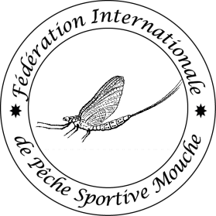
Ver 2021
Olympic Ideals
FIPS-Mouche International Sport Fly Fishing Federation

STATEMENT ON THE OLYMPIC IDEALS

On behalf of the competitors in the "number of the championship”^{th} FIPS-Mouche "categorie” Fly Fishing Championships we pledge to uphold the traditions of the Olympic ideal; to foster friendship and understanding among all people throughout the World and to maintain the FIPS-Mouche tradition of fair play and sportsmanship in our sport.

