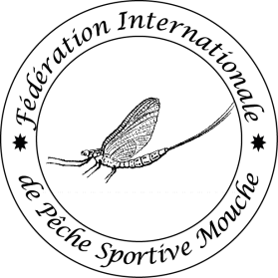
Inspection Agreement
Ver 2021
FIPS-Mouche International Sport Fly Fishing Federation

This is an agreement (in double) on the organisation of a FIPS-Mouche Championship, signed by the representative of the Host Country Federation or Organisation, responsible for the correct enrolment of this championship following the most current FIPS-Mouche Competition rules, Statutes and the FIPS-Mouche Guidelines.

Date: Place:

For the Host Country: For FIPS-Mouche:

1. FIPS-Mouche official carrying out inspection:

Name & address:

tel:

e-mail:

2. International Organiser: Nominated in accordance with Reference A Art 5.2(c)

Name and address:

tel:

e-mail:

Experience at local, National level or World level:

Knowledge of FIPS-Mouche Competition Rules and experience in application:

3. Championship Programme:

Detailed programme (attached at Annex A), including all timings, to be available at start of inspection:

Name & date of the Championship:

4. Estimated attendance –

(numbers of participants for calculation of Participation Fee):

Number of teams entered, or assumed, at date of inspection:
(For WORLD championships: just 1 national team allowed )

Total Team members: (max of 8 per team):

Team Guests & Visitors:

National officials:

FIPS-Mouche officials: max. 3 at World & 2 at European (in single rooms)

FIPS-Mouche International Supervisors: max. 5 ( in twins or single rooms)

Guests of Honour: -

5. Accommodation:

Hotels, names, official grade, number of rooms by type and total beds:

Hotel for officials (board + international Supervisors in the same main hotel):

All in-country cost related to the presence and activities of the Board and the International Supervisors for the whole duration of the official program of the championship will be included in the budget of the championship.
The Board (in single rooms) and the International Supervisors (in twin bedded rooms) will be accommodated together in the main championships hotel, where meetings, draw, results, meeting/secretary rooms are and where are all facilities for printing, producing and showing of the results.

Distances between if hotels are not together:

Meeting rooms: Jury Meetings (10+), Captains Meetings (40+) & presentation

facilities:

Discrete room for input of results:

Internet connections in all rooms:

Chalet/lodge Accommodation:

Arrangements for early arrivals (contact details and facilities available):

Championship/Registration Office – In main hotel or separate: easy access for registrants:

National flags to be flown throughout:

6. External catering:

Arrangements for lunches during championships:

Out-of-hotel events:

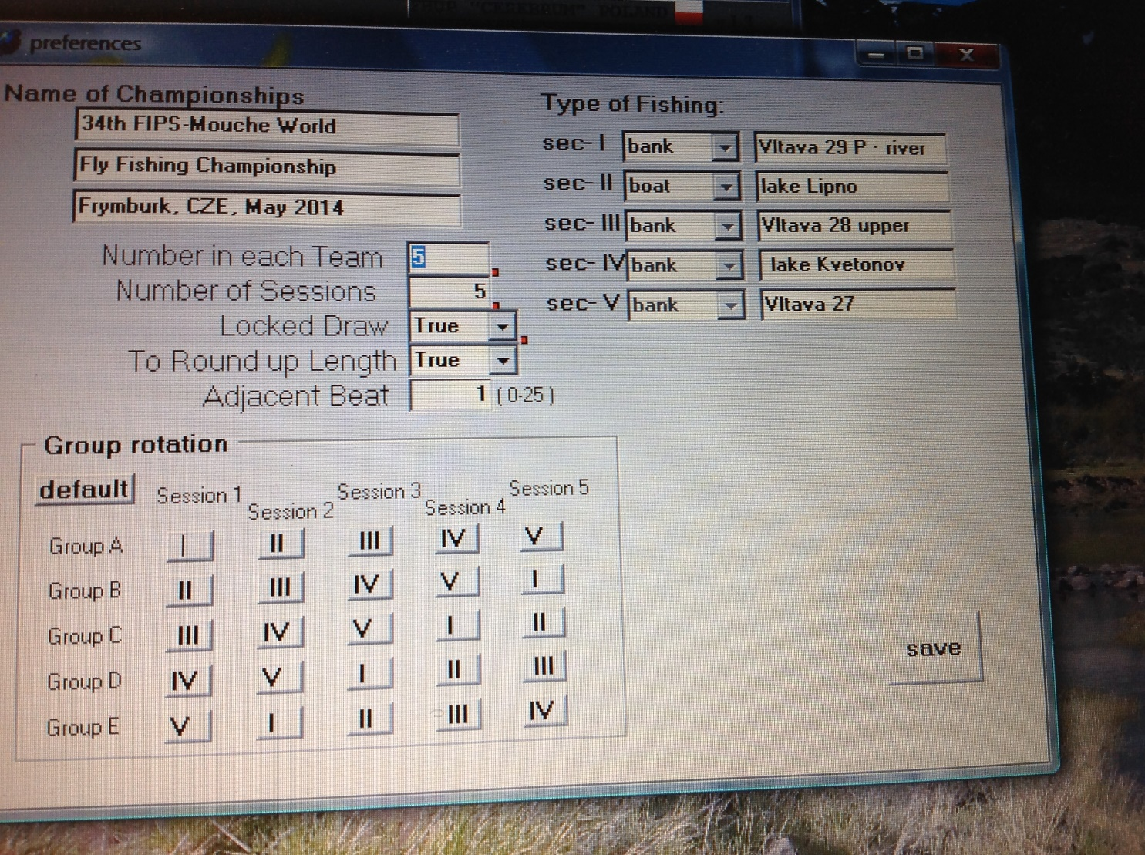
Sector I: Include details including, Name, Average length of beat and Buffer zones, Fish species

Sector II: Include details including, Name, Average length of beat and Buffer zones, Fish species

Sector III: Include details including, Name, Average length of beat and Buffer zones, Fish species

Sector IV: Include details including, Name, Average length of beat and Buffer zones, Fish species

Sector V: Include details including, Name, Average length of beat and Buffer zones, Fish species

All eligible fish must have a minimum size of 20 cm or more

8. Official Practice waters: ( Reference A: Article )

Name/fishing style:

Name/fishing style:

Name/fishing style:

Name/fishing style:

Sufficient area and boats of similar size and construction as competition boats:

Details of transport and timings to be agreed before first Captains’ meeting:

9. Unofficial Practice waters: ( Reference A: Article )

Name: River or Lake
Species:

Name: River or Lake
Species:

Name: River or Lake
Species:

Name: River or Lake
Species:

Extremities of Competition Sectors not to be made available for unofficial practice

Guides/ interpreters and costs:

10. Draw: (Reference A: Article 2.1)

FIPS-Mouche secret draw method mandatory:

LCD projector and screen required:

Desktop computer with Windows XP to Windows 7, keyboard, screen, mouse and compatible printer required:

FIPS-Mouche will oversee draw and results:

Table tennis balls required for draw of Teams and Competitors:

Markings:
1 set from 1 to total number of teams
1 set from A to C, D or E depending on the number of Groups.

11. Scoring and Results:

System for collection/transmission catches from Sectors (detailed description of document transmission/delivery with tested and proved timings):

Scoring card example, following the FIPS-Mouche Template (carbon copy!)

Back-up computer + mandatory use of FIPS-Mouche scoring program:

Two computer operators required to input results:

Board for display of results (up to 50 A4 pages and accessible to public and Competitors):

Fast Photocopier required + paper + stapler+ 25 A4 envelopes + markers

12. Transport: (Reference B: Standards)

System for meeting incoming teams (arrangements at airport/hotel/Tourist Centre:
Details for communication/bookings):

System for moving competitors, controllers & officials
means of transport,

distances/times to and between the sectors,

locations,

meeting points etc

During official practice during Championships:

Timings (including time for competitors to prepare before each session - 30 minutes) :

Safety margins and back up (to be described in detail at inspection)

Car or transport provided for FIPS-Mouche board during the championship

13. Ceremonies: (Reference B: Ceremonies)

All Media rights for all FIPS-Mouche Championships are owned by FIPS-Mouche:

For any championship, only one awards ceremony is authorized and permitted, and it will be at the final/Closing Ceremony. No other types of presentations will be allowed announcing the winners of the Championship.

Sound system and loudspeakers:

Medals provided by FIPS-Mouche:

National Anthems-to be brought by teams and checked when medallists known:

French interpretation, as a minimum, to be provided

National flags available

14. Conservation Symposium: (Reference B: Symposium )

Obligatory at World level:

Must meet agreed criteria

15. Guest Programme:

Outline Programme (Reference B: Application)

16. Budget and Finance ( Reference A: Article 6.1(f) and Reference B)

Budget Template to be completed

Participation Cost-Team member

Participation Cost-Guest :
For senior World: anti-doping tests (4 pers) : +/- 1250€

25 € FIPS-Mouche fee per registrant (4b & 4c) to be paid by Hosts:
FIPS-Mouche bank details:
Banque et Caisse d’Epargne de l’Etat – L-2954 Luxembourg
Bank Address BIC (Swift) : BCEELULL
Account n IBAN: LU62 0019 0038 5693 7000 ( € EURO)

500 € CIPS fee for Championship payable to CIPS Treasurer, before start of the competition:
CIPS bank details:
CREDIT AGRICOLE VAL DE FRANCE
IBAN (International Bank Account Number): FR76 1440 6001 6390 0025 7407 084
Code BIC (Bank Identification Code) - code swift: AGRIFRPP844

17. Insurance: (Reference A: Article 8.1)

Extent of Insurance Cover arranged by Hosts

18. Safety and Security

Local threats –

Liaison with local police

Health precautions –

Medical support:

Date: Place:

For the Host Country: For FIPS-Mouche:

