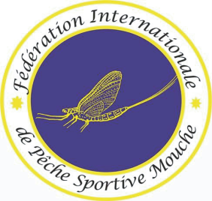

**39th World Fly Fishing Championship**

**Tasmania 30 Nov - 8 Dec 2019**

Minutes of 1st captain meeting

30 Nov 14:30 to 16:00

**Roll call**

All countries were present at the meeting.

**Introduction of organizing team**

Glenn Eggleton, international organiser (IO), Malcolm Crosse ( CD ), presented the team for this championship

**Introduction of FIPS-Mouche Team**

Edoardo Ferrero (2st Vicepresident), Stefan Allacker (General Secretary).

International supervisors were assigned to groups . Rivers only : Paul Dewar and either SA of EF

**Selection of Jury**

International Organiser, the two FIPS-Mouche rep’s, Head of International supervisor team with team captains from :

South Africa (Gerrit Redpath) , USA (Bret Bishop), NL ( Peter Elberse ) will form the jury.

**Draw**

The draw was completed and saved on the secure FIPS-Mouche PC.   
Colour code for groups A to E . The copies will be made by IO for captains and distributed later on.

Captains are responsible for picking the proper colour badges for their competitors based on the draw results.

**Practice details**

None : teams go venue of their choice. There are no designated practice waters.

**OAB**

The IO gave some details on timings regarding the opening ceremony and banquet

**Second captain’s meeting at 17:30 on 1 Dec**

The blank substitution forms will be provided at the 2nd CM.

Further details on the competition sectors, as on stocking of sectors will be on the agenda of the second captains meeting, same location as 1st CM.