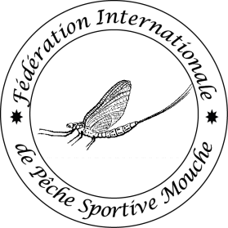
Member Application Form
Ver 2021
FIPS-Mouche International Sport Fly Fishing Federation

MEMBERSHIP APPLICATION FORM

Applicant Federation
Name:
Country:
Street:
Town: |  | Zip code:
Email: |  | Website:
Phone: |  | Fax:

SPOC | Single point of contact (e.g. secretary, president, head of FF committee...)
First name: |  | Surname:
Email: |  | Phone:

Competition stats
(can be estimated)
Number of competitors in your federation:
Number of recreational (no-comp) fly fishers in your federation:
Number of FF competitions organized annually:

Hereby I apply for membership in FIPS-Mouche as “Ordinary” / ”Candidate” Member (pick one category only, explanation see in Statutes) and declare that:
- I took note of the FIPS-Mouche Statutes and Competition rules (current version available on the FIPS-Mouche website www.fips-mouche.com )
- I took note of the CIPS Statutes (current version available on the CIPS website www.cips-fips.com)
- our federation complies with and will adhere to both FIPS-Mouche and CIPS Statutes and Rules.

Motivation for becoming a Member:
Application process:
- Fill-in all above required fields
- Attach a copy of Statutes of the Applicant Federation
- Attach a copy of Certification of Eligibility of Applicant Federation to represent its country in fly fishing issued by National Authority
- Copy/scan of signed Application form + Statutes + Certification send to the following two instances:
- CIPS secretariat
Postal address: Viale Tiziano 70, IT-00196 Roma, Italy
Email: cipssecretariat@cips-fips.com
- FIPS-Mouche General Secretary
Postal address: Stefan Allacker, Tiensestraat 77,3320 Hoegaarden, Belgium
Email: stefan.allacker@skynet.be

Date of submission (DD/MM/YYYY) :

Signature of the President  of Applicant Federation | Stamp of the Applicant Federation  (if applicable)

